**PREFACE**

We take an opportunity to present the project report on “Electronic Voting Machine Using 8051 Microcontroller” and put before users some useful information about our project.

We have made sincere attempts and taken every care to present this matter in precise and compact form.

We are sure that the information content in this volume would certainly prove useful for better insight in this scope and dimension of the subject.

The task of completing the project though being difficult but was made quite simple ,interesting and successful due to deep involvement and complete dedication of our group members.

**ACKNOWLEDGEMENT**

We acknowledge our Project guides, Prof. Junaid Mandviwala for the guidance and valuable suggestions during the entire course of the Mini Project titled “Electronic Voting Machine Using 8051 Microcontroller”.

We also acknowledge with thanks Prof. R.S.Deshmukh, Head of the Department of Electronics and Telecommunication Engineering for the support and facilities in the labs.

We thank our beloved Principal Dr.Varsha J Shah, for her continued support and encouragement and motivating us.

We record our thanks to our friends in our class for interaction and help during the course of the Mini Project.

Chinmay Bawdhankar

Bhunia Susmita

Vishwajeet Chafekar

Dave Priya

**ABSTRACT**

Electronic Voting Machine (EVM) is a simple electronic device used to record votes in place of ballot papers and boxes which were used earlier in conventional voting system. Fundamental right to vote or simply voting in elections forms the basis of democracy. All earlier elections be it state elections or centre elections a voter used to cast his/her favourite candidate by putting the stamp against his/her name and then folding the ballot paper as per a prescribed method before putting it in the Ballot Box. This is a long, time-consuming process and very much prone to errors. This situation continued till election scene was completely changed by electronic voting machine. No more ballot paper, ballot boxes, stamping, etc. all this condensed into a simple box called ballot unit of the electronic voting machine. Because biometric identifiers cannot be easily misplaced, forged, or shared, they are considered more reliable for person recognition than traditional token or knowledge based methods. So the Electronic voting system has to be improved based on the current technologies viz., biometric system. This article discusses complete review about voting devices, Issues and comparison among the voting methods and biometric EVM.

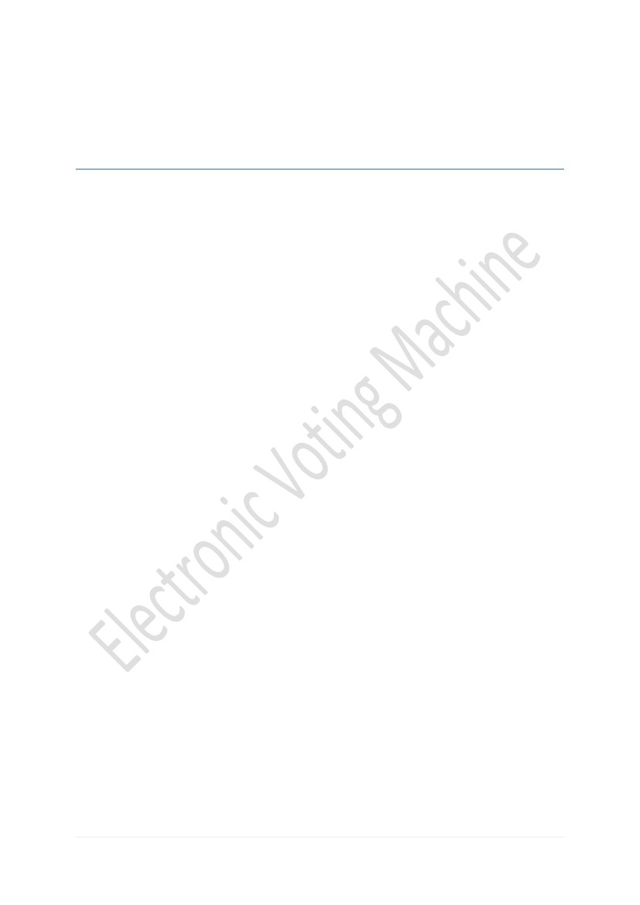

**CONTENTS**

|  |  |  |
| --- | --- | --- |
| **Chapter No.** | **Topic** | **Pg. No.** |
|  | * List of figure * List of Table | **05**  **05** |
|  | **Overview** | **06** |
|  | **Introduction** | **07** |
|  | **Objective** | **09** |
|  | **Literature Survey** | **10** |
| **Chapter 5**    **Chapter 6**  **Chapter 7** | **Related Theory**  **Tools To Be Used**  **Conclusion** | **11**  **23**    **27** |
|  | **References** |  |

**List of figure**

|  |  |  |
| --- | --- | --- |
| FIGURE NO. | LIST | PAGE NO. |
| Fig 2 | Block Diagram of Electronic Voting Machine Controller and ballot unit | 8 |
| Fig 5.1 | Circuit Diagram of Electronic Voting Machine | 11 |
| Fig 5.2(c) | Internal block diagram of 8951 microcontroller | 12 |
| Fig 5.2(d) | Pin diagram of 8951 | 14 |
| Fig 5.3.1 | LCD Display | 16 |
| Fig 5.3.2 | ATS89C51Microcontroller | 16 |
| Fig 5.3.3 | Crystal Oscillator | 17 |
| Fig 5.3.4 | Push Buttons | 18 |
| Fig 5.3.5 | Preset Resistors | 19 |
| Fig 5.4(a) | Bottom layout | 20 |
| Fig 5.4(b) | Real World | 20 |
| Fig 6.B.1 | Copper plated PCB | 24 |
| Fig 6.B.2 | PCB Drilling machine | 25 |

**List of Table**

|  |  |  |
| --- | --- | --- |
| TABLE NO. | LIST | PAGE NO. |
| Table 5.2(e) | Pin description of 8951 | 14 and 15 |

**Chapter 1**

**OVERVIEW**

EVM stands for Electronic Voting Machine. This makes polling much fast and is more reliable then ballot papers, by preventing bogus voting to a great extent. The EVMs save considerable time, money and manpower. It also helps in maintaining the secrecy of individual voting. At the end of polling, just press the button and there you have the result. The EVMs are devised and designed by Election Commission of India in collaboration with two public sector undertakings

EVMs were first used in 1982 in the by election to Parur assembly constituency of Kerala for 50 polling stations.

In 1980, Mr. M. B. Haneefa invented the first Indian voting machine, gazetted "Electronically operated vote counting machine" (Gazette: 191/Mass/80, 15 October 1980). His original design (using Integrated Circuits) was exhibited to the public in Government Exhibitions held in six cities across [Tamil Nadu](http://en.wikipedia.org/wiki/Tamil_Nadu). The EVMs were commissioned in 1989 by [Election Commission of India](http://en.wikipedia.org/wiki/Election_Commission_of_India) in collaboration with [Electronics Corporation of India Limited](http://en.wikipedia.org/wiki/Electronics_Corporation_of_India_Limited). The Industrial design of the EVMs were faculty members at the Industrial Design Centre, [IIT Bombay](http://en.wikipedia.org/wiki/IIT_Bombay) .

**Chapter 2  
INTRODUCTION**

Indian voting machines use a two-piece system with a balloting unit presenting the voter with a button (momentary switch) for each choice connected by a cable to an electronic ballot box. An EVM consists of two units, control unit and balloting unit. The two units are joined by a five-meter cable. The control unit is with the presiding officer or a polling officer and the balloting Unit is placed inside the voting compartment. Instead of issuing a ballot paper, the officer in-charge of the Control Unit will press the Ballot Button. This will enable the voter to cast his vote by pressing the blue button on the balloting unit against the candidate and symbol of his choice. The controller used in EVMs has its operating program etched permanently in silicon at the time of manufacturing by the manufacturer. No one (including the manufacturer) can change the program once the controller is manufactured.

EVMs are powered by an ordinary 6 volt alkaline battery manufactured by [Bharat Electronics Limited](http://en.wikipedia.org/wiki/Bharat_Electronics_Limited), [Bangalore](http://en.wikipedia.org/wiki/Bangalore) and Electronic, [Hyderabad](http://en.wikipedia.org/wiki/Hyderabad,_India). This design enables the use of EVMs throughout the country without interruptions because several parts of India do not have power supply and/or erratic power supply and due to the low voltage, there is absolutely no risk of any voter getting an electric shock. An EVM can record a maximum of 3840 votes and can cater to a maximum of 64 candidates. There is provision for 16 candidates in a single balloting unit and up to a maximum of 4 units can be connected in parallel. The conventional ballot paper/box method of polling is used if the number of candidates exceeds 64. It is not possible to vote more than once by pressing the button again and again. As soon as a particular button on the balloting unit is pressed, the vote is recorded for that particular candidate and the machine gets locked. Even if one presses that button further or any other button, no further vote will be recorded. This way the EVMs ensure the principle of "one person, one vote".

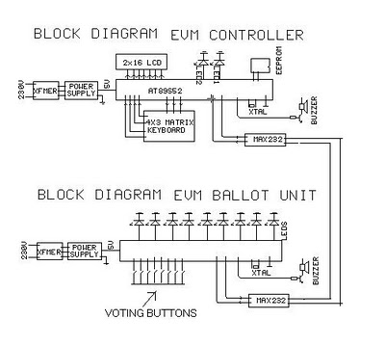

**Fig 2.Block Diagram of EVM Controller and EVM Ballot Unit**

**Chapter 3**

**OBJECTIVE**

This project presents a way to develop an electronic voting machine which displays the count of votes on a 16x2 LCD interface. A user can get his/her vote register through a set of switches. After every cast of vote, the subsequent count can be seen on LCD.The circuit uses microcontroller ATS89C51 and the code for the project has been written in C. Thus the objective of our project is to design a prototype for preferential electronic voting machine that serves the election process where preferential is conducted with low cost of implementation and to carry out an highly effective polling process.

#### Chapter 4

#### LITERATURE SURVEY

**By Diponkar Paul and Sobuj Kumar Ray,Member,LACSIT theoretically states that** [Voting is m](mailto:sobuj_kumar_ray@yahoo.com)[ost pivotal process](mailto:dipo0001@ntu.edu.sg) of democratic society through which people determine its government. Governments around the world are increasingly considering the replacement of traditional paper-based voting schemes with electronic voting systems. Elections of Bangladesh are conducted most exclusively using electronic voting machines developed over the past three years. In this paper we describe the design, construction and operation of a digital voting machine using a microcontroller profoundly. Again we also portray counting system of votes, market survey and cost analysis. This work contributed to three very basic research questions arising: in the context of verifiable elections. First, we discussed the problem of keeping ballot secrecy to a certain extent in the case of a corrupted doting machine or voting authority. Our contribution to this is an approach where all secret information is encapsulated in the voting machine. Second, we considered the attack of receipt stealing and manipulation of the corresponding votes. Here we proposed a novel approach of linking all receipts by a hash chain such that each single receipt guards the integrity of all receipts issued previously. Together with a display in the polling place this approach shortens the time window in which an adversary can perform the ballot stealing attack without almost zero risk. Third, we discussed in detail the possibility of contesting an election based on the evidence provided by the verifiable election scheme. We compared the situation for Bingo Voting to the evidence provided by paper based schemes. We shortly sketched an approach to prove an error or a manipulation in the voting booth without violating ballot secrecy. However, this was only a proof of concept and for a practical application the usability of this approach needs to be further improved.

**Chapter 5**

#### RELATED THEORY

#### 5.1CIRCUIT DIAGRAM

#### Circuit diagram of the Electronic Voting Machine Using 8051 Microcontroller can be seen below:

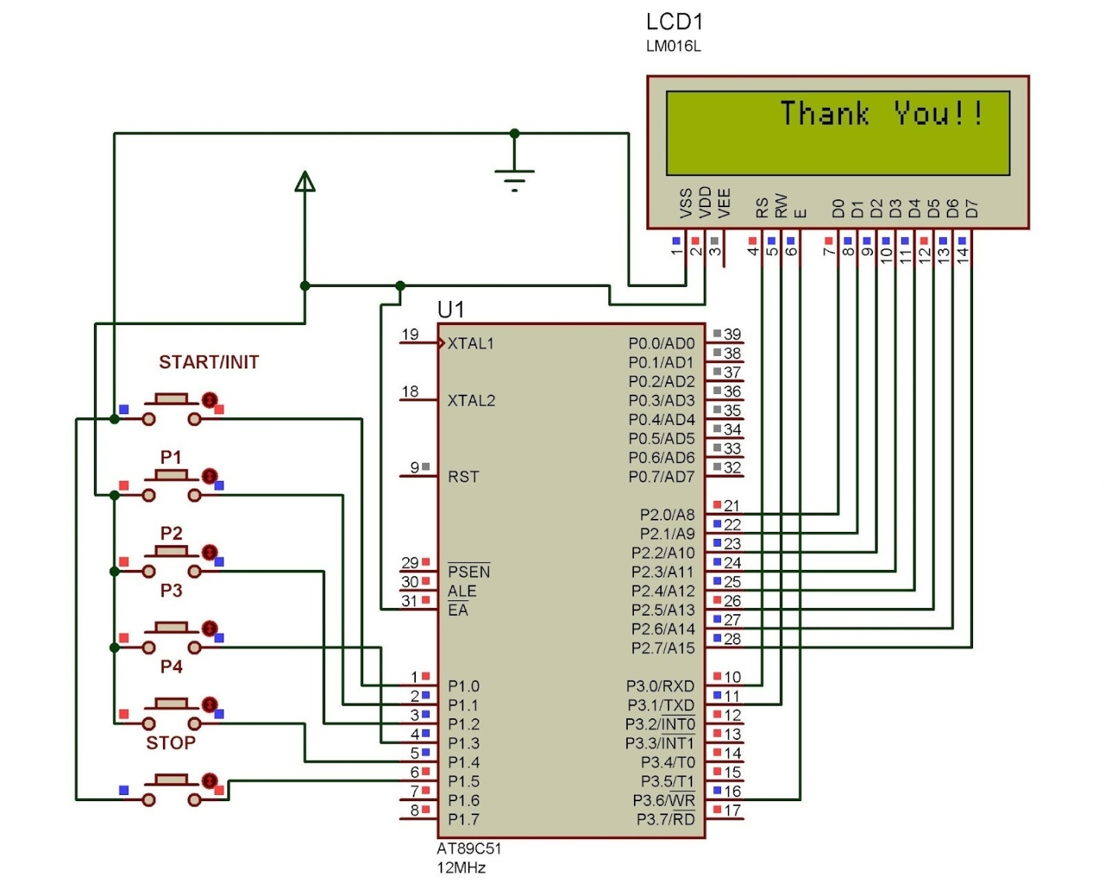

**Fig 5.1 Circuit Diagram of Electronic Voting Machine**

**5.2 IC 8951 MICROCONTROLLER**

**5.2(a) Introduction to 8951:**The AT89C51 is a CMOS 8-bit microcomputer with 4K bytes of Flash programmable and erasable read only memory (PEROM).  The on-chipFlash allows the program memory to bereprogrammed in-system or by a ordinary nonvolatile memory programmer. Atmel AT89C51 is a powerful microcomputer/microcontroller (as they are used inter-changeably) which provides a highly-flexible and cost-effective solution to many embedded control applications

#### 5.2(b) Features of AT89C51

* 128 bytes of RAM for storing running program,
* 32 I/O lines for communicating with other devices,
* two 16-bit timer/counters,
* a five vector two-level interrupt architecture,
* a full duplex serial port, on-chip oscillator and clock circuitry.

**5.2(c) Internal block diagram of 8951 microcontroller**

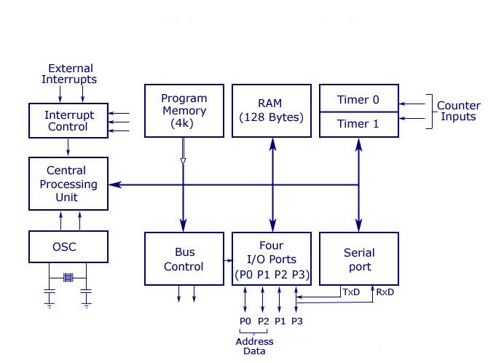

**Fig 5.2(c) Internal Block Diagram of 8951 Microcontroller**

**Central Processor Unit (CPU)**: CPU is the brain of any processing device. It monitors and controls all operations that are performed in the Microcontroller. User has no control over the work of CPU. It reads program written in ROM memory and executes them and do the expected task.

**Interrupts**: Interrupt is a subroutine call that interrupts Microcontroller's main operation or work and causes it to execute some another program which is more important at that time. The feature of Interrupt is very useful as it helps in cases of emergency. Interrupts gives us a mechanism to put on hold the ongoing operation , execute a subroutine and then again resumes normal program execution The Microcontroller 8951 can be configured in such a way that it temporarily terminates or pause the main program at the occurrence of interrupt. When subroutine is completed then the execution of main program starts as usual. There are five interrupt sources in 8951 Microcontroller. 2 of them are external interrupts, 2 timer interrupts and one serial port interrupt.

**Input/output Port**: Microcontroller is used in embedded systems to control the operation of machines. Therefore to connect it to other machines, devices or peripherals we require I/O interfacing ports in Microcontroller. For this purpose Microcontroller 8951 has 4 input output ports to connect it to other peripherals.

**Timers/Counters**: Microcontroller 8951 has 2 16 bit timers and counters. The counters are divided into 8 bit registers. The timers are used for measurement of intervals, to determine pulse width etc.

**Oscillator**: Microcontroller is a digital circuit device, therefore it requires clock for its operation. For this purpose, Microcontroller 8951 has an on-chip oscillator which works as a clock source for Central Processing Unit. As the output pulses of oscillator are stable therefore it enables synchronized work of all parts of 8951 Microcontroller.

**Bus**: Basically Bus is a collection of wires which work as a communication channel or medium for transfer of Data. These buses consist of 8, 16 or more wires. Thus these can carry 8 bits, 16 bits simultaneously. Buses are of two types:  
You May Also Like: [Advantages and Applications of Microcontroller](http://www.wikiforu.com/2012/10/applications-of-microcontroller.html)  
Address Bus, Data Bus

**Address Bus**: Microcontroller 8051 has a 16 bit address bus. It used to address memory locations. It is used to transfer the address from CPU to Memory.

**Data Bus**: Microcontroller 8051 has 8 bits data bus. It is used to carry data.

**5.2(d) Pin Diagram of 8951**

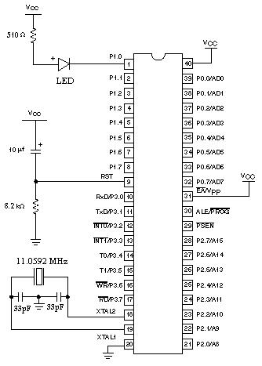

**Fig 5.2(d) Pin Diagram of 8951 Microcontroller**

**5.2(e) Table: Pin description of 8951**

|  |  |  |  |  |
| --- | --- | --- | --- | --- |
| **Pin No** | **Function** | | | **Name** |
| 1 | 8 bit input/output port (P1) pins | | | P1.0 |
| 2 | P1.1 |
| 3 | P1.2 |
| 4 | P1.3 |
| 5 | P1.4 |
| 6 | P1.5 |
| 7 | P1.6 |
| 8 | P1.7 |
| 9 | Reset pin; Active high | | | Reset |
| 10 | Input (receiver) for serial communication | RxD | 8 bit input/output port (P3) pins | P3.0 |
| 11 | Output (transmitter) for serial communication | TxD | P3.1 |
| 12 | External interrupt 1 | Int0 | P3.2 |
| 13 | External interrupt 2 | Int1 | P3.3 |
| 14 | Timer1 external input | T0 | P3.4 |
| 15 | Timer2 external input | T1 | P3.5 |
| 16 | Write to external data memory | Write | P3.6 |
| 17 | Read from external data memory | Read | P3.7 |
| 18 | Quartz crystal oscillator (up to 24 MHz) | | | Crystal 2 |
| 19 | Crystal 1 |
| 20 | Ground (0V) | | | Ground |
| 21 | 8 bit input/output port (P2) pins  /  High-order address bits when interfacing with external memory | | | P2.0/ A8 |
| 22 | P2.1/ A9 |
| 23 | P2.2/ A10 |
| 24 | P2.3/ A11 |
| 25 | P2.4/ A12 |
| 26 | P2.5/ A13 |
| 27 | P2.6/ A14 |
| 28 | P2.7/ A15 |
| 29 | Program store enable; Read from external program memory | | | PSEN |
| 30 | Address Latch Enable | | | ALE |
| Program pulse input during Flash programming | | | Prog |
| 31 | External Access Enable;  Vcc for internal program executions | | | EA |
| Programming enable voltage; 12V (during Flash programming) | | | Vpp |
| 32 | 8 bit input/output port (P0) pins    Low-order address bits when interfacing with external memory | | | P0.7/ AD7 |
| 33 | P0.6/ AD6 |
| 34 | P0.5/ AD5 |
| 35 | P0.4/ AD4 |
| 36 | P0.3/ AD3 |
| 37 | P0.2/ AD2 |
| 38 | P0.1/ AD1 |
| 39 | P0.0/ AD0 |
| 40 | Supply voltage; 5V (up to 6.6V) | | | Vcc |

**5.3 COMPONENT DESCRIPTION**

**5.3.1 LCD DISPLAY**

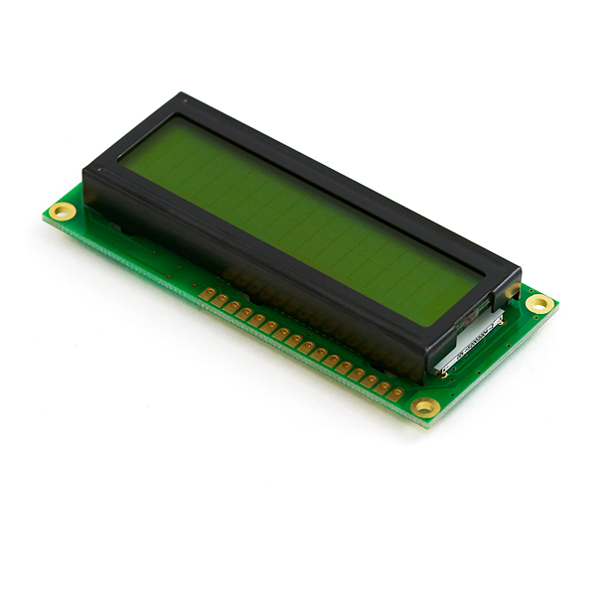

**Fig 5.3.1 LCD Display**

Liquid Crystal Display which is commonly known as LCD is an Alphanumeric Display it means that it can display Alphabets, Numbers as well as special symbols thus LCD is a user friendly Display device which can be used for displaying various messages unlike seven segment display which can display only numbers and some of the alphabets. The only disadvantage of LCD over seven segment is that seven segment is robust display and be visualized from a longer distance as compared to LCD. Here we have used 16 x 2 Alphanumeric Display which means it can display two lines with maximum of 16 characters in one line.

**5.3.2 ATS89C51 MICROCONTROLLER**

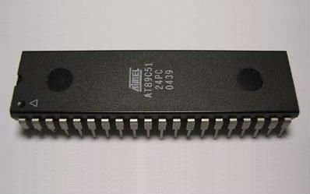

**Fig 5.3.2 ATS89C51 Microcontroller**

The AT89S52 is a low-power, high-performance CMOS 8-bit microcontroller with 8K bytes of in system programmable Flash memory. The device is manufactured using Atmel’s high-density non-volatile memory technology and is compatible with the industry-standard 80C51 instruction set and pin out. The on-chip Flash allows the program memory to be reprogrammed in-system or by a conventional non-volatile memory programmer. By combining a versatile 8-bit CPU with in-system programmable Flash on a monolithic chip, the Atmel AT89S52 is a powerful microcontroller, which provides a highly flexible and cost-effective solution to many, embedded control applications. The AT89S52 provides the following standard features: 8K bytes of Flash, 256 bytes of RAM, 32 I/O lines, Watchdog timer, two data pointers, three 16-bit timer/counters, a six-vector two-level interrupt architecture, a full duplex serial port, on-chip oscillator, and clock circuitry. In addition, the AT89S52 is designed with static logic for operation down to zero frequency and supports two software selectable power saving modes.

**5.3.3 CRYSTAL OSCILLATOR**

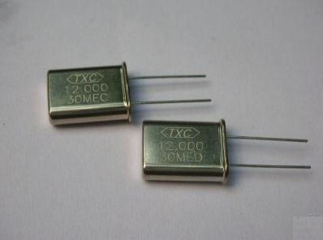

**Fig 5.3.3 Crystal Oscillator**

A **crystal oscillator** is an electronic oscillator circuit that uses the mechanical [resonance](http://en.wikipedia.org/wiki/Resonance) of a vibrating [crystal](http://en.wikipedia.org/wiki/Crystal) of piezoelectric material to create an electrical signal with a very precise frequency. This frequency is commonly used to keep track of time (as in [quartz wristwatches](http://en.wikipedia.org/wiki/Quartz_clock)), to provide a stable [clock signal](http://en.wikipedia.org/wiki/Clock_signal) for [digital](http://en.wikipedia.org/wiki/Digital_data) integrated circuits, and to stabilize frequencies for radio transmitters and [receivers](http://en.wikipedia.org/wiki/Radio_receiver). The most common type of resonator used is the [quartz](http://en.wikipedia.org/wiki/Quartz) crystal, so oscillator circuits incorporating them became known as crystal oscillators, but other piezoelectric materials including polycrystalline ceramics are used in similar circuits. Quartz crystals are manufactured for frequencies from a few tens of [kilohertz](http://en.wikipedia.org/wiki/Kilohertz) to hundreds of megahertz. More than two billion crystals are manufactured annually. Most are used for consumer devices such as [wristwatches](http://en.wikipedia.org/wiki/Wristwatch), [clocks](http://en.wikipedia.org/wiki/Clock), [radios](http://en.wikipedia.org/wiki/Radio), [computers](http://en.wikipedia.org/wiki/Computer), and [cell phones](http://en.wikipedia.org/wiki/Cellphone). Quartz crystals are also found inside test and measurement equipment, such as counters, [signal generators](http://en.wikipedia.org/wiki/Signal_generator), and oscilloscope

**5.3.4 PUSH BUTTONS**

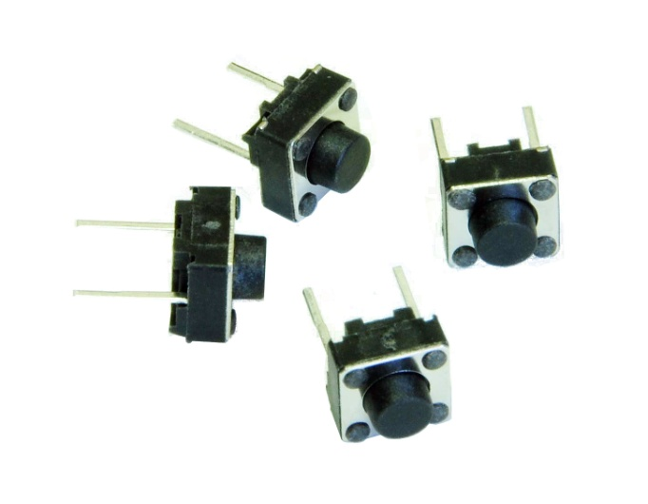

**Fig 5.3.4 Push Buttons**

A push-button (also spelled pushbutton) or simply button is a simple switch mechanism for controlling some aspect of a [machine](http://en.wikipedia.org/wiki/Machine) or a [process](http://en.wikipedia.org/wiki/Process_(engineering)). Buttons are typically made out of hard material, usually [plastic](http://en.wikipedia.org/wiki/Plastic) or [metal](http://en.wikipedia.org/wiki/Metal). The surface is usually flat or shaped to accommodate the human finger or hand, so as to be easily depressed or pushed. Buttons are most often [biased switches](http://en.wikipedia.org/wiki/Switch#Biased_switches), though even many un-biased buttons (due to their physical nature) require a [spring](http://en.wikipedia.org/wiki/Spring_(device)) to return to their un-pushed state. Different people use different terms for the "pushing" of the button, such as press, depress, mash, and punch.

The "push-button" has been utilized in [calculators](http://en.wikipedia.org/wiki/Calculators), [pushbutton telephones](http://en.wikipedia.org/wiki/Push-button_telephone), kitchen appliances, and various other mechanical and electronic devices, home and commercial.

**5.3.5 PRESET RESISTORS**

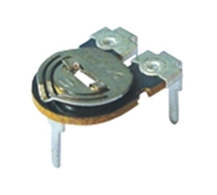

**Fig 5.3.5 Preset Resistors**

The [resistor](http://www.electrical4u.com/types-of-resistor-carbon-composition-and-wire-wound-resistor/) whose electrical resistance value can be adjusted as per requirement by adjustable component attached to it is called **variable**[resistor](http://www.electrical4u.com/types-of-resistor-carbon-composition-and-wire-wound-resistor/). It is an electronic component. It is applied in an electronic circuit for adjusting circuit resistance to control [voltage](http://www.electrical4u.com/voltage-or-electric-potential-difference/) or [current](http://www.electrical4u.com/electric-current-and-theory-of-electricity/) of that circuit or part of that circuit This is micro version of variable [resistor](http://www.electrical4u.com/types-of-resistor-carbon-composition-and-wire-wound-resistor/). Preset [resistor](http://www.electrical4u.com/types-of-resistor-carbon-composition-and-wire-wound-resistor/)s are directly mounted on circuit board and adjusted only when the circuit is built. There is an adjustable screw attached to the [resistor](http://www.electrical4u.com/types-of-resistor-carbon-composition-and-wire-wound-resistor/) and a small screwdriver is required to adjust this screw for desired resistance value. These [resistor](http://www.electrical4u.com/types-of-resistor-carbon-composition-and-wire-wound-resistor/)s are quite cheaper than standard variable [resistor](http://www.electrical4u.com/types-of-resistor-carbon-composition-and-wire-wound-resistor/) available in the market.

**5.4 PCB LAYOUT**

The PCB Layout of the solder side of the circuit has been made using PCB Wizard Software.

**(A)Bottom layout**

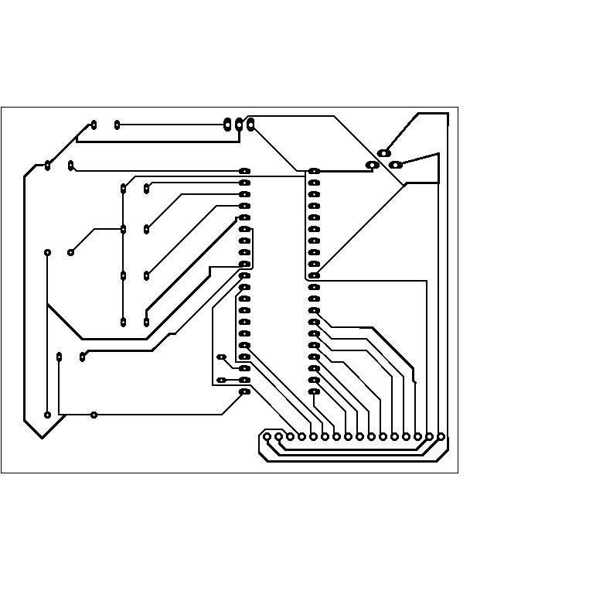

**Fig 5.4(a) Bottom Layout**

**(B) Real world**

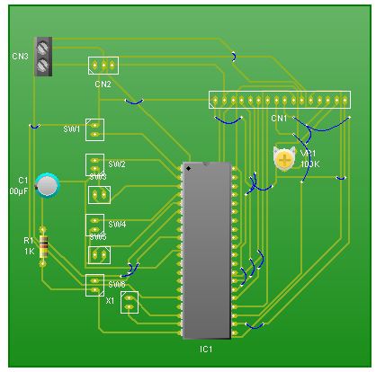

**Fig 5.4(b) Real world**

**5.5 CIRCUIT OPERATION**

#### OPERATION OR WORKING OF CIRCUIT

The voting is started by pressing the Init switch after which the user is prompted to vote. The count of votes is stored in four different variables. As soon as the user votes for a candidate by pressing one of the switches, the value of the corresponding variable is increased by one. After this a Thank you message is displayed on LCD to acknowledge the registration of user’s vote. The message stays on the screen until the next user either presses the Init button to cast another vote or Stop switch is pressed get the poll results. When the stop button is pressed, the names of the candidates are displayed along with their vote counts. After some delay, the result is displayed which could be either declaration of the winner candidate or the candidates with a clash of their number of votes. Algorithm shown below as follows:

1] Mode selection:  
i. Voting mode: toggle switch on VCC  
ii. Counting mode: toggle switch on GND.  
Voting Mode: When toggle switch is in voting mode “Voting mode” is displayed followed by “Please vote”. After a vote being given, “Please wait for authority switch” is displayed and again enable for voting after Control switch being pressed by the voting Authority.  
Counting Mode: When toggle switch is in counting mode “Counting mode” in displayed on the screen, and total number of votes to respective candidate can be displayed on the screen by pressing the respective key assigned to them.  
3] Clear mode: Press clear switch when all entries are required to be erased. Clear switch should be pressed before voting procedure.  
4] Controller switch: This switch is provided for enabling the keypad in voting mode. This switch is under the control of voting authority.

**5.6 SCOPE OF PROJECT**

1. It is economical.

2. Less manpower required.

3. Time conscious, as less time required for voting & counting.

4. Avoids invalid voting.

5. Saves transportation cost due to its compact size.

6. Convenient on the part of voter.

7. As a future scope it can be used as a GSM Technology.

**5.7 LIMITATIONS**

1. Limited no of candidates.

2. More candidates mean implies complicated circuits.

**5.8 APPLICATIONS**

1. This could be used for voting purpose at any required place.

2. It is used in general elections for choosing candidates to represent people at various stages.

3. It can be used to find the general opinion of people on various issues.

4. Anywhere where majority opinion is to be found out.

**Chapter 6**

**TOOLS TO BE USED**

**(A)SOFTWARE TOOLS**

**6.A.1 PCB LAYOUT WIZARD SOFTWARE**

PCB Wizard is a powerful package for designing single-sided and double-sided printed circuit boards (PCBs).It provides a comprehensive range of tools covering all the traditional steps in PCB production, including schematic drawing, schematic capture, component placement, automatic routing, Bill of Materials reporting and file generation for manufacturing.

**6. A.2 KEIL SOFTWARE**

The Keil 8051 Development Tools are designed to solve the complex problems facing embedded software developers. When starting a new project, simply select the microcontroller you use from the Device Database and the µVision IDE sets all compiler, assembler, linker, and memory options for you. Numerous example programs are included to help you get started with the most popular embedded 8051 devices The Keil µVision Debugger accurately simulates on-chip peripherals (I²C, CAN, UART, SPI, Interrupts, I/O Ports, A/D Converter, D/A Converter, and PWM Modules) of your 8051 device. Simulation helps you understand hardware configurations and avoids time wasted on setup problems. Additionally, with simulation, you can write and test applications before target hardware is available.

**6. A.3 PROTEUS SOFTWARE**

Proteus 7.0 is a Virtual System Modelling (VSM) that combines [circuit simulation,](http://circuit-simulation.software.informer.com/) animated components and microprocessor models to co-simulate the complete microcontroller based designs. This is the perfect tool for engineers to test their microcontroller designs before constructing a physical [prototype in](http://prototype.software.informer.com/) real time. This program allows users to interact with the design using on-screen indicators and/or LED and LCD displays and, it attached to the PC, switches and buttons.One of the main [components of](http://components1.software.informer.com/) Proteus 7.0 is the Circuit [Simulation --](http://simulation1.software.informer.com/) a product that uses a SPICE3f5analogue [simulatorker](http://simulator.software.informer.com/)nel combined with an event-driven digital simulator that allow [users to](http://users3.software.informer.com/) utilize any SPICE model by any manufacturer.Proteus VSM comes with extensive debugging features, including breakpoints, single stepping and variable display for a neat [design prior](http://electronic-design.software.informer.com/) to hardware prototyping.In summary, Proteus 7.0 is the [program](http://program.software.informer.com/) to use when you want to simulate the interaction between software running on a [microcontroller and](http://microcontroller.software.informer.com/) any analog or digital [electronic device](http://electronic-modeling.software.informer.com/) connected to it. Advantages is (1) real time simulation.(2) Time and money saving.

**6.A.4 PIC KIT**

PICkit is a family of programmers for PIC microcontrollers made by Microchip Technology. They are used to program and debug microcontrollers, as well as program EEPROM. Some models also feature logic analyzer and serial communications (UART) tool. PICkit 2 has been an interesting PIC programmer from Microchip. It can program most PICs and debug most of the PICs (as of May-2009, only the PIC32 family is not supported for MPLAB debugging). Ever since its first releases, all software source code (firmware, PC application) and hardware schematics are open to the public. This makes it relatively easy for an end user to modify the programmer for use with a non-Windows operating system such as Linux or Mac OS. In the meantime, it also creates much DIY interest and clones. This open-source structure brings many features to the PICkit 2 community, such as Programmer-to-Go, the UART Tool and the Logic Tool, which have been contributed by PICkit 2 users. Users have also added such features to the PICkit 2 as 4MB Programmer-to-go capability, USB buck/boost circuits, RJ12 type connectors, and more. There are many other USB PIC programmers other than the PICkit series.

**(B)HARDWARE TOOLS**

**6.B.1 COPPER PLATED PCB**



**Fig 6.B.1 Copper Plated PCB**

A printed circuit board (PCB) mechanically supports and electrically connects [electronic components](http://en.wikipedia.org/wiki/Electronic_component) using [conductive](http://en.wikipedia.org/wiki/Electrical_conductor) tracks, pads and other features [etched](http://en.wikipedia.org/wiki/Industrial_etching) from copper sheets [laminated](http://en.wikipedia.org/wiki/Laminated) onto a non-conductive [substrate](http://en.wikipedia.org/wiki/Substrate_%28electronics%29). can be single sided (one copper layer),double sided(two copper layers) or . Conductors on different layers(multi layers) are connected with plated-through holes called via(A via is an electrical connection between layers in a physical electronic circuit that goes through the plane of one or more adjacent layers). Advanced PCBs may contain components - capacitors, resistors or active devices - embedded in the substrate.

**6.B.2 DRILLING MACHINE FOR PCB**

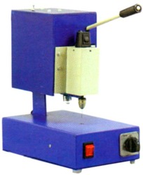

**Fig 6.B.2Drilling Machine for PCB**

A compact tabletop High speed PCB drilling machine with a Quick change Chuck.  
 **Feature:**

* Drill holding by precision chuck with lapped jaws
* Mains operated DC motor Direct drive ( no belt and pulley)
* 3 Step Speed Control and Illumination of work Area

**Specification:**

* Motor Speed  : up to 20,000 R.P.M
* Range  : 0.6 to 3.0 mm
* Base  : Metal
* Working Area  : 280 mm x 170 mm
* Electrical Power  : 230/ 50Hz, 5 A Socket required

**PRECAUTIONS**

**SOLDERING PRECAUTION**

The construction was carried out with care. The precautions taken during the soldering were: The tip of soldering iron was kept clean with the help of a file from time to time. The solder wire was of smaller thickness. Extra solder was not used in order to avoid a cause of short circuit in the conductive path. The overheating of components was avoided to prevent component damage as a result of excessive heat on the components due to the heat from the soldering iron. The leads of the components were kept clean before soldering, with the use of sand paper.

**COMPONENTS PRECAUTION**

I.C should not be heated much while soldering; too much heat can destroy the I.C. For safety and ease of replacement, the use of I.C socket is suggested. While placing the I.C pin no 1 should be made sure at right hole. Each component should be done neatly.

**Chapter 7**

**CONCLUSION AND FUTURE WORK**

In this project, we have described the specification and architecture of a electronic voting machine .Various fault-tolerance and security issues are delegated to the platform itself, therefore relieving the application designer from accommodating these features in the application design itself. This approach allows for the easy development and deployment of applications. For quite some time, voting equipment vendors have maintained that their systems are secure, and that the closed-source nature makes them even more secure. Our glimpse into the code of such a system reveals that there is little difference in the way code is developed for voting machines relative to other commercial endeavours. In fact, we believe that an open process would result in more careful development, as more scientists, software engineers, political activists, and others who value their democracy would be paying attention to the quality of the software that is used for their elections. (Of course, open source would not solve all of the problems with electronic elections. It is still important to verify somehow that the binary program images running in the machine correspond to the source code and that the compilers used on the source code are non-malicious. However, open source is a good start.) Such open design processes have proven successful in projects ranging from very focused efforts, such as specifying the Advanced Encryption Standard (AES) [23], through very large and complex systems such as maintaining the Linux operating System. Australia is currently using an open source voting system10Alternatively, security models such as the voter-verified audit trail allow for electronic voting systems that produce a paper trail that can be seen and verified by a voter. In such a system, the correctness burden on the voting terminal’s code is significantly less as voters can see and verify a physical object that describes their vote. Even if, for whatever reason, the machines cannot name the winner of an election, then the paper ballots can be recounted, either mechanically or manually, to gain progressively more accurate election results. Voter-verifiable audit trails are required in some U.S. States, and major DRE vendors have made public statements that they would support such features if their customers required it. The EVM project an ambitious attempt to create an open-source voting system with a voter-verifiable audit trail a laudable goal The model where individual vendors write proprietary code to run our elections appears to be unreliable, and if we do not change the process of designing our voting systems, we will have no confidence that our election results will reflect the will of the electorate. We owe it to ourselves and to our future to have robust, well-designed election systems to preserve the bedrock of our democracy.

**REFERENCES**

For a paper in a Proceedings/Transactions/Journal

International Journal of Information and Electronics Engineering,Vol 3,No.2,March 2013. By Diponkar Paul and Sobuj Kumar Ray,Member,LACSIT.

For an authored book

1. Muhammad Ali Mazidi-“The 8051 Microcontroller and Embedded Systems”.

2. Ayala- “Introduction to 8051 Microcontroller”.

3.”Architecture and Programming of 8051 Microcontroller” by Milan Verle.

4.”Introduction to Microcontrollers” by Gunther Gridling and Bettina Weiss.

For a website

1. http://grietinfo.in/projects/MINI/EEE/DOC-A.17EVM.pdf

2.http://students.iitk.ac.in/eclub/assets/documentations/summer09/ElectronicVotingMachine.pdf

3. <http://www.ijiee.org/papers/295-JI174.pdf>

4.http://www.hbeonlabs.com/%20New%20Folder/ELECTRONIC%20VOTING%20MACHINE.pdf

**APPENDIX**

|  |  |  |  |
| --- | --- | --- | --- |
| Sr no. | Components | Quantity required | Price(in rupees) |
| 1 | LCD Display | 1 | 130 |
| 2 | Microprocessor AT89C51 | 1 | 45 |
| 3 | Push Buttons | 4 | 16 |
| 4 | Crystal Oscillator | 1 | 25 |
| 5 | Connecting Wires | 1 | 10 |
| 6 | Preset Resistors | 1 | 10 |
| Total |  |  | 236 |

**COMPONENT LIST AND PRICE**